

DATA POLICY #CR2060

MIS Gear Up Student Activity Codes

Type of Action (check all that apply):
X | New Policy |  | Change to Existing Policy
 | New Data Field to Collect |  | Change to Existing Data Fields

Term Effective:

Fall Semester 2018 (201912)

Date Created: July 9, 2018
Revised:
Revised:

Reason for Action:

New data policy – new student activity codes defined.

Reason for Policy:

To have a mechanism to identify credit students who are enrolled in a technical college and identified as one of the two Gear Up initiatives. The two new activity codes are:

GUGAP – “Priority Strategy” – This activity code is used to identify students who are enrolled and have experienced homelessness or have been in the foster care system. Students in this strategy are 9th, 10th, 11th and 12th grade students recruited across identified Georgia counties.

GUGAC – “Cohort Strategy” – This activity code is used to identify students who are enrolled and are in those districts with high levels of students who are impoverished, homeless and in foster care. This model will follow 7th and 8th grade students through middle and high school on through their first year of college (Cohort Students).

Policy:

The appropriate student/learner activity code must be entered on the Banner SGASTDN Activities form each term a student is enrolled and identified in one of the Gear Up initiatives.

Procedure:

- The Gear Up activity codes of “GUGAP” and “GUGAC” must be defined in STVACTC (just once, to setup for use)
CODE | DESCRIPTION
GUGAP | Priority Strategy.
GUGAC | Cohort Strategy.

- For each semester of enrollment, the learner activity code of “GUGAP” or “GUGAC” must be entered in SGASTDN Activities Banner form for each student participating in one of the Gear Up initiatives.
- The Data Center will collect student enrollment in these initiatives beginning fall semester 2018 (201912).

Retired Policies:

None

Action After Approval:

- The Data Center will modify the extraction program.
- The Data Center and the Office of Technical Education will notify the colleges of this new policy.

APPROVAL

Steve Brown, Director of IMS  Data Resources  Technical College System of Georgia | Date |  | Dianne Barker, Director  Secondary Education Initiatives  Technical College System of Georgia | Date

NOTE:
Data policies and procedures are primarily meant to assist colleges with data entry validation and verification. While also serving as a means to enforce policies and procedures as set in the State Board Policy Manual, the Technical Education Program Standards, state and federal regulations, and other sources, unresolved errors may be allowed with appropriate approval. However, if left unresolved, the related data will not be included in system records/reports.

Sample Screens for Data Entry:

- The activity codes of “GUGAP” and “GUGAC” must be defined in STVACTC (just once, to setup for use)
CODE | DESCRIPTION
GUGAP | Priority Strategy.
GUGAC | Cohort Strategy.

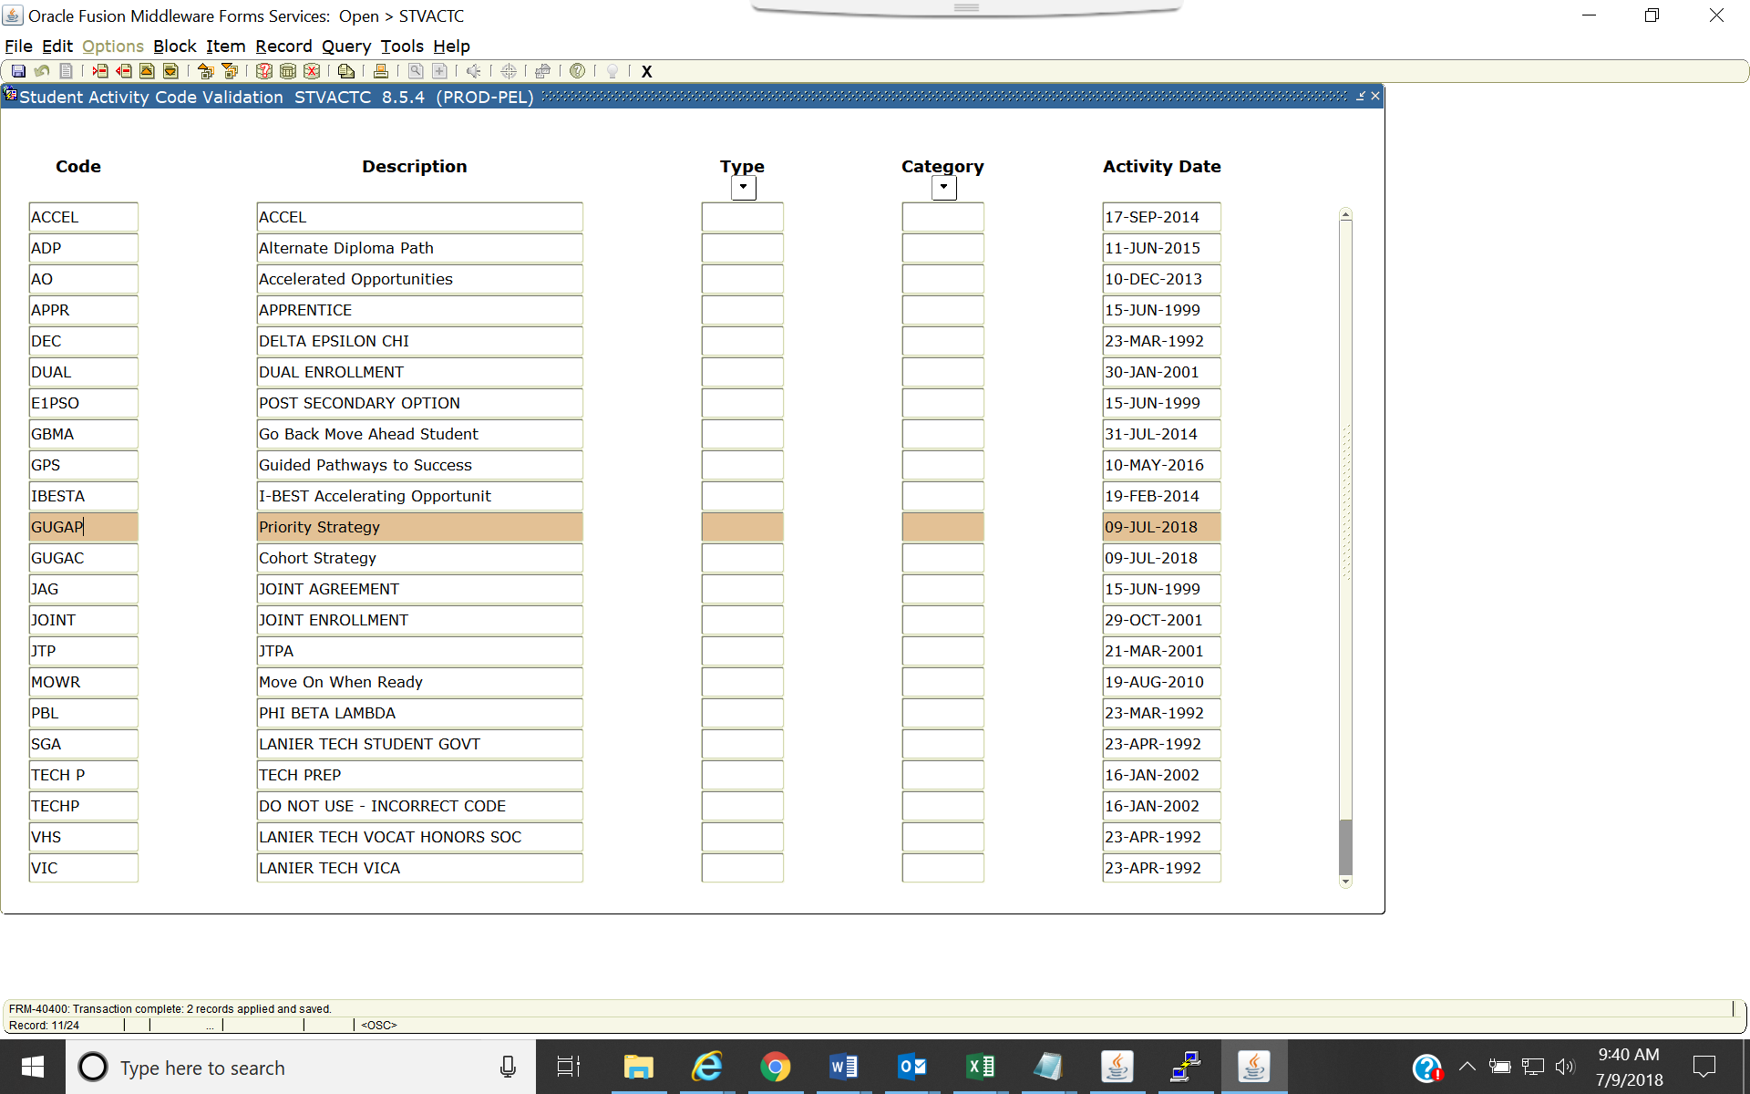

- For each semester of enrollment, the learner activity code of “GUGAP” or “GUGAC” must be entered in SGASTDN Activities Banner form for each enrolled credit student participating in a Gear Up initiative.

